DATABASE PROJECT

QUERY EXAMPLES

---Query containing a WHERE clause and a multi-table join

---An example of a query containing a where and a multi-table join --What is the total price of orders above $90

use GroupFive;

go

select firstname as [First Name],

LastName as [Last Name],

sum(price) as [Total of all Orders]

from Person join Order2

on Person.PersonID = Order2.PersonID

where price > 90

group by FirstName, LastName;

---What employee start times were in the afternoon on a specific day

select firstname as [First Name],

LastName as [Last Name],

Starttime as [Shift Start Time]

from Person join Employee_Order

on Person.PersonID = Employee_Order.PersonID

where Starttime > '2021-11-20 12:00:00.000' and Starttime < '2021-11-21 00:00:00.000';

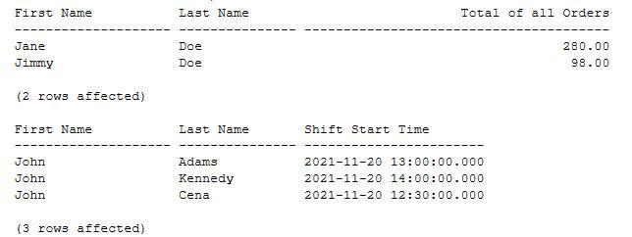

---Query containing a join with a set operator (Carolyn Shea)

---An example of a join query using the except operator.

---What products did we sell more than 1 of?

use GroupFive;

select od.productID as [Product ID]

* o2.orderdate as [Order Date]
* prd.productdescription [Description]
* prd.productsize as [Size]
* od.orderdetailqty as [Number Sold] from order_detail od join order2 o2

on od.orderdetailID = o2.orderID

join product prd

on od.productid = prd.productid

except

select od.productID

* o2.orderdate
* prd.productdescription
* prd.productsize
* od.orderdetailqty

from order_detail od join order2 o2

on od.orderdetailID = o2.orderID

join product prd

on od.productid = prd.productid

where od.orderdetailqty <= 1

order by od.productID;

Result:

| -------------------------*/ |  |  |  |
| --- | --- | --- | --- |
| Product ID Order Date Description | Size Number Sold | |  |
| ----------- ---------- -------------------------------------------------- ---- ----------- | |  |  |
| 1066 2021-11-20 COTTON BASIC SHIRT | XXL |  | 2 |
| 1105 2021-11-20 TIPPED SWEATER POLO | M |  | 3 |
| 1204 2021-11-20 LACE CAMI | XXL |  | 3 |
| 1234 2021-11-20 HERRINGBONE BEADED TANK |  | XXL | 5 |
| 1265 2021-11-20 SEQUIN COWL NECK SLEEVELESS TOP | | XS | 2 |
| 1278 2021-11-20 LACE FIT AND FLARE DRESS |  | S | 6 |

(6 rows affected)

—--------------------------------------------------------------------------------------------------------------------------------------

---Query containing a Subquery and an outer join

---An example of a Subquery

---A listing of customers' first name, last name, and total purchases for only those that have average purchases that are greater than the average of all purchases .

use GroupFive;

select FirstName [First Name]

* LastName [Last Name]
* sum(price) as [Total Purchases] from person p join Order2 o

on p.PersonID = o.PersonID group by FirstName, LastName having avg(Price) >=

(select avg(price) from Order2)

order by [Total Purchases] desc;

Result:



---An example of an Outer Join.

---A listing of all customers and their order if present.

use GroupFive;

Go

select c.PersonID [Person ID]

* CustomerSince [Customer Since] ,OrderID [Order ID]
* Price
* OrderDate [Order Date]

from Order2 o full join Customer c

on o.PersonID = c.PersonID;

Result:

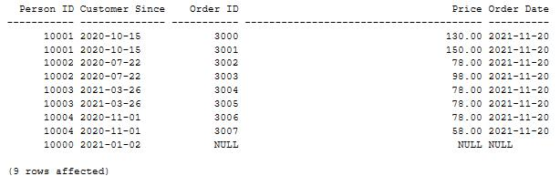

---Query containing a group by statement

---An example of a query using the group by statement.

How many times was each promotion used?

use GroupFive;

select pro.promotionID as [Promotion ID]

* promotionPercentage as [Promotion %]
  + count(od.promotionID) as [Total Used] from Promotion pro join order_detail od

on pro.promotionID = od.promotionID group by pro.promotionID, promotionPercentage order by pro.promotionID;

------------------------*/

Promotion ID Promotion % Total Used

------------ ----------- -----------

| 2000 | 10 | 3 |
| --- | --- | --- |
| 2001 | 20 | 1 |
| 2002 | 35 | 1 |
| 2003 | 50 | 1 |
| 2004 | 75 | 2 |

(5 rows affected)

--Query containing a having statement

* filtering the total orders that are more than $150 use GroupFive;

go

select firstname as [First Name], LastName as [Last Name], sum(price) as [Total of all Orders]

from Person join Order2

on Person.PersonID = Order2.PersonID group by FirstName, LastName having sum(price) > 150;

Result:

